In this lab you will learn:

1. *Introduction to digital ICs.*
2. *Reading data sheet and finding the specs.*
3. *Using IC's with the breadboard.*
4. *Verifying an IC's functionality.*

# Working in the Laboratory - Parts and Equipment

## Working with a digital integrated circuit (IC):

The “building blocks” for creating digital circuits are called logic devices, consisting of gates, flip-flops, decoders, counters, etc. Logic devices are constructed from semiconductor electronic devices, such as diodes and transistors, and passive electrical components (primarily resistors). The type of transistor used and/or the manner in which the transistor is used separates logic devices into distinct logic families. Examples of logic families include CMOS (Complementary Metal Oxide Semiconductor), ECL (Emitter- Coupled Logic), and TTL (Transistor-Transistor Logic). TTL had been the logic family of choice for many small designs because it is relatively inexpensive and not easily damaged. However, CMOS is supplanting TTL because it is also relatively inexpensive, dissipates significantly less power, has higher speed and greater functionality. In addition, most large-scale devices, e.g. memories and CPU’s, are implemented in CMOS.

Within the CMOS family, there are several subfamilies or series including Highspeed CMOS (HC), High- speed CMOS, TTL compatible (HCT), Advanced High-speed CMOS (AHC), and Advanced High-speed CMOS, TTL compatible (AHCT). These subfamilies differ primarily in speed and power consumption. In general, you can use different series devices in the same circuit, although to be save you should verify this. We will primarily use HCT in this course.

Because of advances in semiconductor technology, it is now possible to place millions of electrical components on a single piece of silicon, called an integrated circuit or simply IC, for short. (ICs are also referred to as chips.) ICs are typically very small (occupying less area than your smallest fingernail), requiring fine wires (about the diameter of a hair) for connections. Consequently, to be useful as a circuit element, ICs must be suitably packaged.

Although somewhat confusing, the terms chip and IC are also used to refer to packaged integrated circuits. ICs come in a variety of plastic or ceramic packages with connecting pins designed for mounting on printed circuit boards. The most useful package for building prototype circuits is the Dual Inline Package or DIP, which has two rows of pins that conveniently insert into your breadboard. Pins are labelled numerically starting at 1, and each DIP package is marked to identify pin 1. In most cases, the package has a notch at the top or a small dimple adjacent to pin 1 (Figure 1)

### Handling integrated circuits:

It is important to be careful when handling integrated circuits. ICs, especially CMOS, are very sensitive to static electricity. So, when you sit down to work with ICs, it is a good idea to first touch a metal object that is grounded in order to discharge any static. This is especially true in the winter, when the dry air exaggerates this problem. Also, avoid clothing and chairs that tend to generate static. In commercial settings, special conductive wristbands are worn by anyone handling ICs. If not handled properly, static

discharge may destroy the device, or significantly shorten its lifespan. So be careful, you will not be issued an unlimited supply of components.

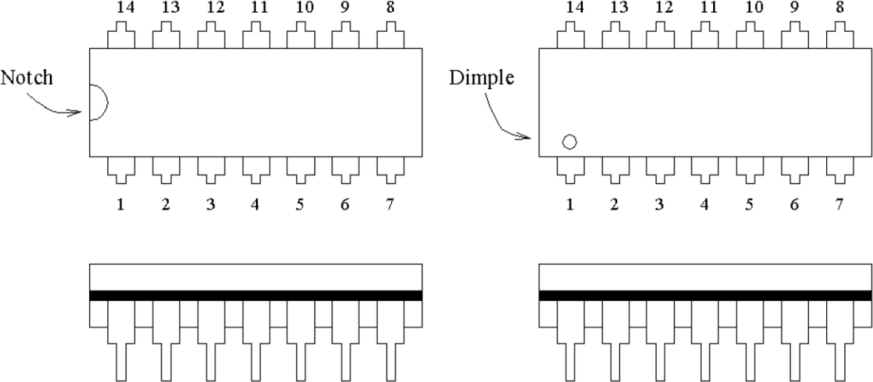

*Figure 1 Pin configuration for a typical 14-pin DIP IC. The dimple or notch indicates the position of pin 1.*

### Reading Datasheets

To produce reliable hardware designs, you must be able to read the IC data sheets provided by the manufacturer. A variety of data sheets for CMOS and TTL devices are available from the Texas Instruments web site. A typical data sheet for a CMOS NAND gate is shown in Figure 2.

Each IC is identified by a part number. Each part number begins with an alphabetic prefix, indicating the manufacturer (e.g., SN for Texas Instruments and DM for National Semiconductor). This is followed by the number 54 or 74, indicating military grade or commercial grade ICs respectively. Specifications differ for the two grades, so it is important to read the data sheet correctly. However, we will always use commercial grade (74) ICs in this course. The next component of the part number is an alphabetic code for the CMOS series, e.g. HCT for the devices we will use. Next is a number indicating the type of logic device (e.g., NAND gate, inverter, decoder, etc.). Finally, there is an alphabetic suffix indicating the package type. For example, the part number CD74HCT00E indicates that the IC is a quadruple (i.e., four gates in one package) 2-input NAND gate (00), constructed from high-speed CMOS, TTL compatible (HCT), manufactured by Texas Instruments (CD (originally Harris)), of commercial grade (74), and housed in a plastic DIP package (E).

Each data sheet provides one or more diagrams showing the relationship between the pins on the package and the function of the device (Figure 2). This is often referred to as the IC pin-out. For the 'LS001 pins 1 and 2 are inputs to one of the 2-input NAND gates, and pin 3 is the corresponding output. Three other gates in the same package have similar connections. All ICs require power, a DC voltage and current, so each package must provide pins for the supply voltage (referred to as VCC and ground (GND)). For commercial grade ICs in a DIP package, VCC is ALMOST always opposite pin 1 and GND is in the opposite corner. There are exceptions, however, so be sure to read the data sheet before using an unfamiliar IC.

The functional characteristics of a device are described either as a truth table, Boolean expression, logic diagram, or via an IEEE standard logic symbol [not shown for this chip], or some combination of these. The data sheet also provides electrical specifications for the IC.

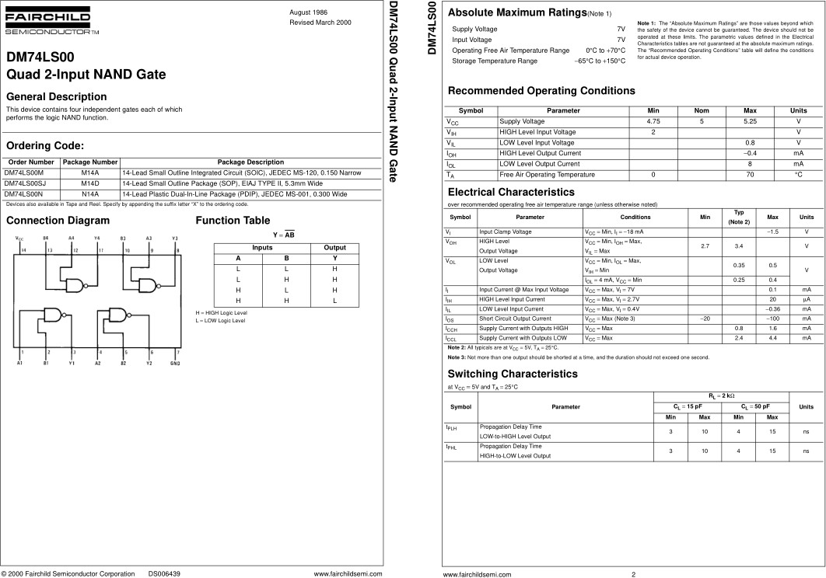

*Figure 2 Screenshot of data sheet for a quad 2-input NAND gate, description and functional diagrams- page 1(L) and 2(R)*

## Mounting an IC on the breadboard

You already know that a breadboard is just an array or matrix of holes housing tiny electrical contacts. The contacts are designed to accept the pins of DIP ICs, other electronic parts, and connecting wires. ICs and other devices are plugged into the breadboard straddling the center trough (the center shaded area in Figure 3 Note: your board will probably have several troughs. You may use any trough). Thus, the pins on one side of an IC will insert into the holes in area A, and the pins on the other side will insert into the holes in area B. Note that holes in area A are electrically isolated from the holes in B. Also, each of the five holes in any vertical column (area A or B) are tied together internally but isolated from all other columns. Interconnections between IC pins are made using short pieces of telephone wire, available in the bins provided to you. For example, if we want to connect pin 1 to pin 5, a wiring connection is made between any hole in the column occupied by pin 1 and any hole in the column occupied by pin 5.

All ICs require both VCC and GND connections. VCC and GND connections are made from your power supply to your breadboard via terminals provided for that purpose. Then using connecting wire, you must route VCC from the banana jack to one of the four VCC/GND buses illustrated in Figure 3 (your board may have more buses). A similar connection is required for GND, using a different bus, of course. Each bus

consists of a single row of holes all tied together internally. So, after you connect a bus to the terminal, you can make power connections to your ICs from any hole in the bus. Note that on some breadboards, a single row may be divided into two or more buses.

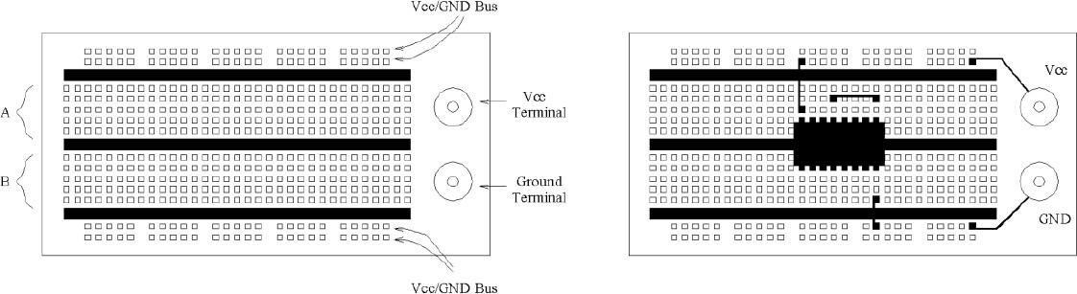

*Figure 3 (Left)Typical breadboard for circuit prototyping consisting of a matrix of holes providing electrical contacts. ICs and other components plug into the board straddling the center trough (center shaded area). (Right) Example of a 16-pin DIP IC inserted in breadboard.*

# Activities

## Activity 1: Reading a datasheet:

Go to the TI web site and find the data sheet for a NOR device. You may download the data sheet if you wish, or simply view it from the web browser. Answer the following questions as a part of your final report:

[https://www.ti.com/lit/ds/symlink/cd4001b.pdf?ts=1599317323619&ref_url=https%253A%252F%252Fwww.ti.com%252Fstore%252Fti%](http://www.ti.com/lit/ds/symlink/cd4001b.pdf?ts=1599317323619&ref_url=https%253A%252F%252Fwww.ti.com%252Fstore%252Fti%25) 252Fen%252Fp%252Fproduct%252F%253Fp%253DCD4001BM

1. What pins connect to Vcc and to ground? (give the pin numbers)

*For all models of this IC, Vcc (Vdd) is pin 14 and Gnd (Vss) is pin 7*

1. What kind of functionality does this device has?

*This device is specifically a NOR gate with buffer functionality. These ICs can have multiple NOR gates with 2 to 4 inputs, this IC were working on in this lab will only have two inputs with four NOR gates (CD4001B)*

***Include your answers to these questions in your final document***

## Validating the functionality of the logic gate

While doing the connections of the IC make sure that you connect the power at the end. This helps you avoiding short-circuits. If you have already done the previous activities, you will notice, most of ICs are two input quart ICs (there are 4 of the same gates inside them). Remember that, for a two-input digital gate, you have 4 combinations for the truth table. If you work smart, you can validate the full truth table in one go. Once you check all the connections are proper, give power supply to the IC. Use an LED to validate the output voltages in the pins. ***Make an observation table for different combinations of inputs.*** A sample table is given below. You do not need to fill in this table below!

IC Functionality: **AND**

𝑉𝑐𝑐 value: 5V

|  |  |  |  |
| --- | --- | --- | --- |
| IN-1 logic | IN-2 logic | OUT logic | Expected OUT Logic |
| 0 | 0 | 0 | 0 |
| 0 | 1 | 0 | 0 |
| 1 | 0 | 0 | 0 |
| 1 | 1 | 1 | 1 |

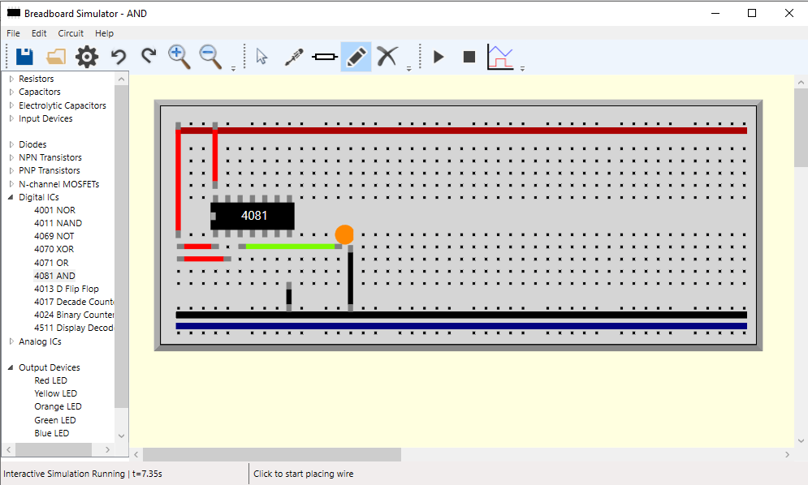

## 

## Activity 2:

*Table 2: Truth table verification for your digital logic gate ICs*

Create 3 tables, one for the NOR gate, one for a NAND gate, and lastly one for a NOT gate. Please follow the table template from above to create the three tables for these gates. Use the IC's on the simulator to test these results, and use an oscilloscope probe to test the input and output voltages for each case. Also please take a screenshot of each IC when using it, so in total we want 3 screenshots (1 for each gate) for one of the input/output combinations from the table.

At the end of this activity you should end up with 3 tables and 3 screenshots. Then put all of these things into one file, along with all of the answers to the questions and submit it as one file.

**NOR**

|  |  |  |  |
| --- | --- | --- | --- |
| IN-1 logic | IN-2 logic | OUT logic | Expected OUT Logic |
| 0 | 0 | 1 | 1 |
| 0 | 1 | 0 | 0 |
| 1 | 0 | 0 | 0 |
| 1 | 1 | 0 | 0 |

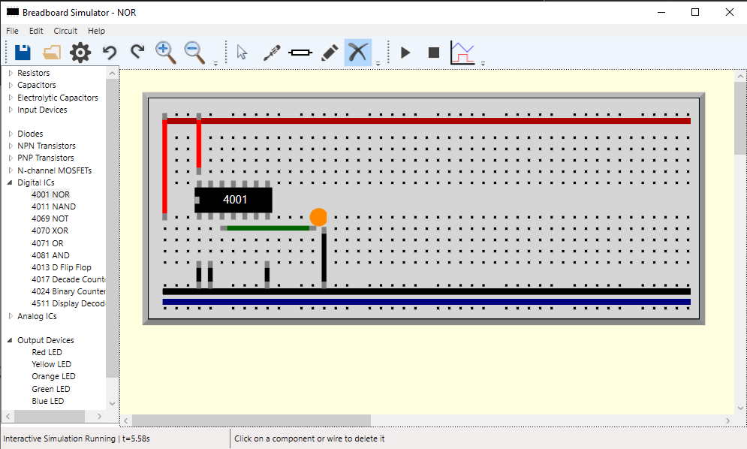

**NAND**

|  |  |  |  |
| --- | --- | --- | --- |
| IN-1 logic | IN-2 logic | OUT logic | Expected OUT Logic |
| 0 | 0 | 1 | 1 |
| 0 | 1 | 1 | 1 |
| 1 | 0 | 1 | 1 |
| 1 | 1 | 0 | 0 |

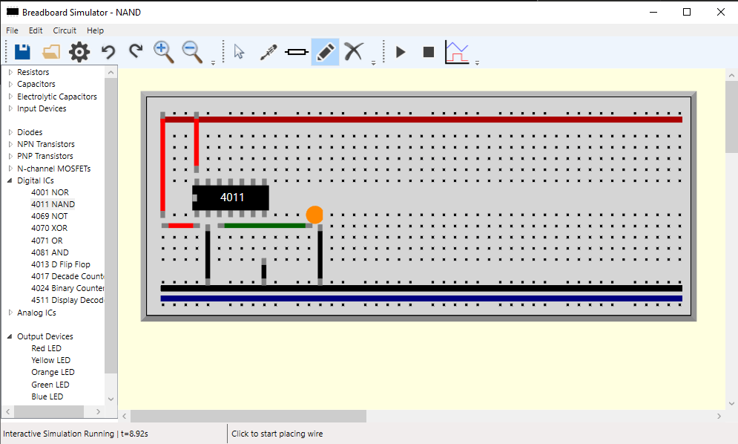

**NOT**

|  |  |  |
| --- | --- | --- |
| IN-1 logic | OUT logic | Expected OUT Logic |
| 0 | 1 | 1 |
| 1 | 0 | 0 |

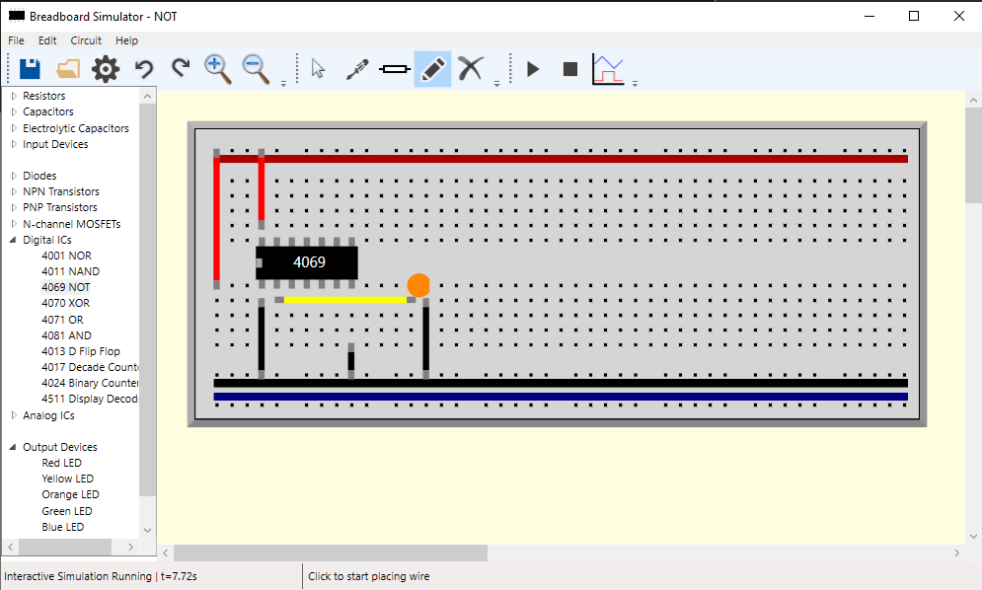

## Additional Question: (not optional, you must answer this)

1. Why do we always put the IC between a trough?

This is to ensure that the IC pins do not connect to each other. If the IC didn’t straddle the middle of the breadboard, all the pins in the same row would be connected, we need them all to have their own row, thus place between a trough.